COMP 3710 Artificial Intelligence
Fall 2016
Term test II

Student Name: Student Number:

- (5 marks) Show whether the following argument is valid or not, using the resolution refutation.
C → D
D → E ∨ F
Therefore C → F

- (5 marks) Here are rules.
- P → Q
- L ∧ M → P
- B ∧ L → M
- A ∧ P → L
- A ∧ B → L
Here are facts (or observations).
- A
- B
Question: Is Q valid?
Solve the above problem using backward chaining. You should show how the algorithm works using the following table.
Facts Goals Matching rules
A, B Q a)

- (3 marks) Consider the inverted pendulum problem. The input for Theta is NS:0.75 and ZE:0.25, and the input for dTheta is ZE:0.3 and PS:0.6. Find the output fuzzy sets with membership values, using the next fuzzy rules. (Note that the numbers after fuzzy sets are membership values.)
 | Theta
dTheta |  | NM | NS | ZE | PS
dTheta | NM |  |  | PM
dTheta | NS |  |  | PS | ZE
dTheta | ZE | PM | PS | ZE | NS
dTheta | PS |  | ZE | NS
dTheta | PM |  |  | NM

- (5 marks) Compute the information gain for Big Star. You do not have to compute the logarithms. (Here are the related formulas.
Information Gain = 1 – ∑ (the weighted entropies)
Entropy = – p₀ × (log₂ p₀) – p₁ × (log₂ p₁) – ...
Film | Country | Big Star | Genre | Success
Film 1 | USA | Yes | SF | True
Film 2 | USA | No | Comedy | False
Film 3 | USA | Yes | Comedy | True
Film 4 | Europe | No | Comedy | True
Film 5 | Europe | Yes | SF | False
Film 6 | Europe | Yes | Romance | False
Film 7 | Other | Yes | Comedy | False
Film 8 | Other | No | SF | False
Film 9 | Europe | Yes | Comedy | True
Film 10 | USA | Yes | Comedy | True

- (6 marks) There are two output nodes in a backpropagation neural networks. The two output nodes are connected to two hidden nodes.
- Weights between the hidden layer and the output layer are 0.2, 0.6, -0.5, and 0.4.
- The outputs from the hidden nodes are 0 and 1.
- The outputs from the output nodes are 0.3 and 0.1. (The values may not be accurate. You can just use them for this question.)
- The expected outputs are 1 and 0.
- The learning rate is α = 0.1.
- The formulas are δ_{k} = y_{k} (1 – y_{k}) e_{k}; w_{jk} = w_{jk} + α y_{j} δ_{k}
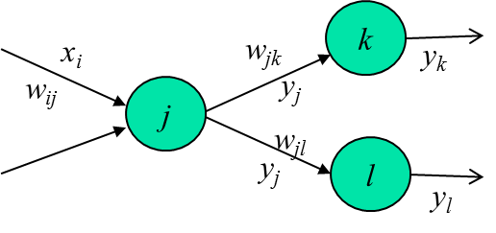
- (1 mark) Draw a diagram showing two layers, outputs, and weights, with the above values.
- (1 mark) Compute the errors.
- (2 marks) Compute the deltas for the output nodes.
- (2 marks) Compute the new weights between the hidden layer and the output layer.

